**JS – Validation**

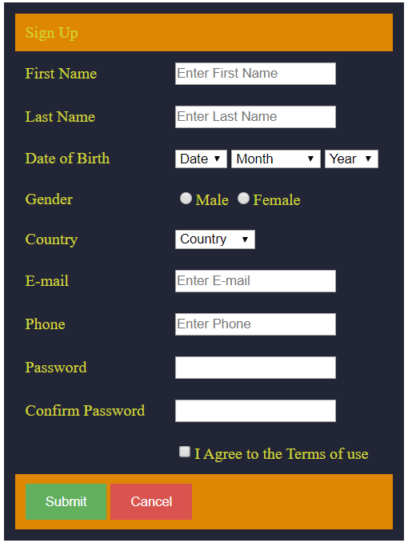

1. Check all input boxes for empty values (If empty give an alert saying "Error: Input is empty!")
2. Validate Email address (The email address should consist of “@” and “.”)
3. Validate Phone number (All the characters should be numbers and length should be 10)
4. Validate password confirmation (Both Password and Confirm Password inputs should be equal)